State Tourism Website to Boost Tourism Revenue of the State of Maharashtra

**Nitika Verma Ritik Agarwal**

**Prof. Maheswari S.**

Department of Computer Science (SCOPE)

Vellore Institute of Technology, Chennai

***Abstract –*** The World Wide Web (WWW) has become the primary instrument used by tourists in order to search for information. As a result, tourism websites pertaining to destinations need to be appealing and must be user friendly. In the website discussed in this paper a user can view the famous tourist locations, culture, festivals, adventure sports and event details of the state of Maharashtra. Research has established that the most important information to users in the initial stage of planning a trip is information that uses textual and visual images of a destination in order to describe the experiences that can be enjoyed in the destination, so our website would focus on multiple picture galleries with an option for the user to upload pictures as well after their visit. The main aim of this project is to highlight the crowd pulling and attractive features of Maharashtra, in order to boost the tourism revenue of the state.

***Keywords: tourism, Maharashtra, adventure, culture, festivals, cuisine, locations, tourism revenue, tourist destinations.***

1. **INTRODUCTION**

Ever since the introduction of the Internet to business applications in the early 1990s, making online reservations for tourism products and

services has turned out to be a popular trend. A Tourism website is a platform dedicated to tour and travel. The site is focused on travel details, tour packages, trip fares, etc. The purpose of this website is to provide travel enthusiasts an all-in-one destination for all their travel plans.

* According to Google, more than 65% of leisure travelers begin researching online before they decide where or how they want to travel, will Offer real time access to the all the data required for planning their trip.

This website would provide users an interactive platform to plan their visit to the state and manage their time efficiently. We will be providing them with all the details they need in duration of their holiday.

This website would also serve as an effective tour guide with its features providing information about various nearby local sites, restaurants and shopping destinations while visiting a major tourist attraction. Hence our website will not only serve the user in planning their trip but will also be helpful throughout their stay.

1. **TECHNIQUES USED**

User Interface is the key part of this project. UI of this website is made using HTML, CSS, Javascript. Bootstrap 3.0 is the key framework used in designing the pages.

Php, Mysql are used for implementing the dynamic component of the website. Tools used for development are VS Code and Xampp.

1. **FEATURES OF THE WEBSITE**

***Main components of the website***

Home page, Exploring destinations pages, Stories/Articles, Documents and referrals, Contact page, Photo and Video Gallery, Social Media share links, Share, Search, and Map.

***Centralized Events and destination***

The page provides information divided under various categories of interest for a traveler – Adventure sports (further divided in to camping, aerial sports, water sports and more), Cultural events, spiritual destinations, heritage, festive events, cuisine etc.

***Interactive and responsive website***

Main purpose of selecting this project was to make the website more appealing and user friendly to the tourists. A more interactive and responsive website draws more attention and excitement to the viewers to visit a place. This would also increase state tourism revenue.

***Social media feeds and links***

They provide the user with experiences and reviews of other tourists who have visited to provide them with a better planning experience.

***Multimedia elements***

They are used to enhance the appeal and usefulness of the website. Website includes Images, Documents, Video and Audio, Content feeds from other websites

including restaurants and hotels, Social media feeds of tourists.

***Custom Maps***

A customized map is added at the bottom of each adventure sub-section that has pin point location of various destinations

***Nearby Facility suggestions***

Suggesting various nearby locations and distance, Activities, Hotels and Restaurants for various destinations***.***

***Weather Forecast API***

Embedded weather forecast API to show the climate and temperature for each tourist destination.

***Feedback page***

For any suggestions, feedback, or any kind of content updation requests can be sent once a user is logged in to our page.

***Login page and User Dashboard***

User can like a destination or adventure sport, and that will be added to the ‘favourites’ tab.

***Search option***

User can search for their favourite destination and directly view its details without manually finding it out on the website.

1. **PROPOSED SYSTEM**

At present, numerous tourism websites have been established in order to capture this promising business opportunity. In spite of the existence of thousands of tourism websites, there is no commonly agreeable standard for evaluating the success or performance of these websites. In academia, tourism researchers have performed different studies to investigate various issues that are related to website features.

When e-Business was firstly introduced to the business world, the main use was to help and promote the hotel and lodging to serve the tourism industry. These methods, however, focuses solely for the promotion of business rather than introducing the user to the various opportunities in that place. In particular, these techniques do not offer any insights on the various other features and landmarks present in that place. This project focuses mainly on promoting the tourism of the state of Maharashtra, by providing the user with information about all the activities, features, wildlife and other destinations that are of interest to the user. This project not only helps in planning the trip but also serves as a tour guide providing nearby restaurants, local landmarks, maps and other features that would help the user during their visit to a particular place, hence focusing mainly on promoting tourism business in the State and providing the user with an all-in-one interface that would serve them throughout their trip.

**COMPARISON TO THE EXISTING WEBSITE**

1. ***Homepage:***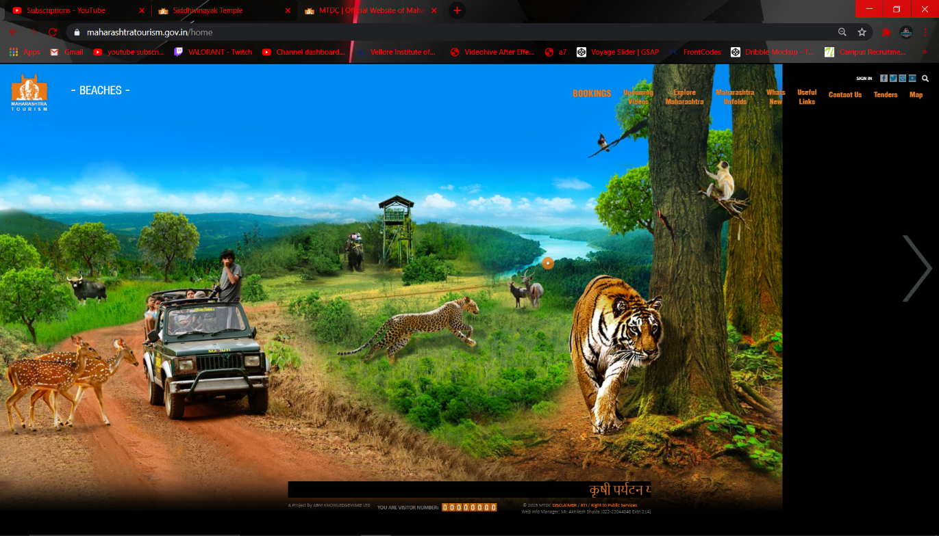 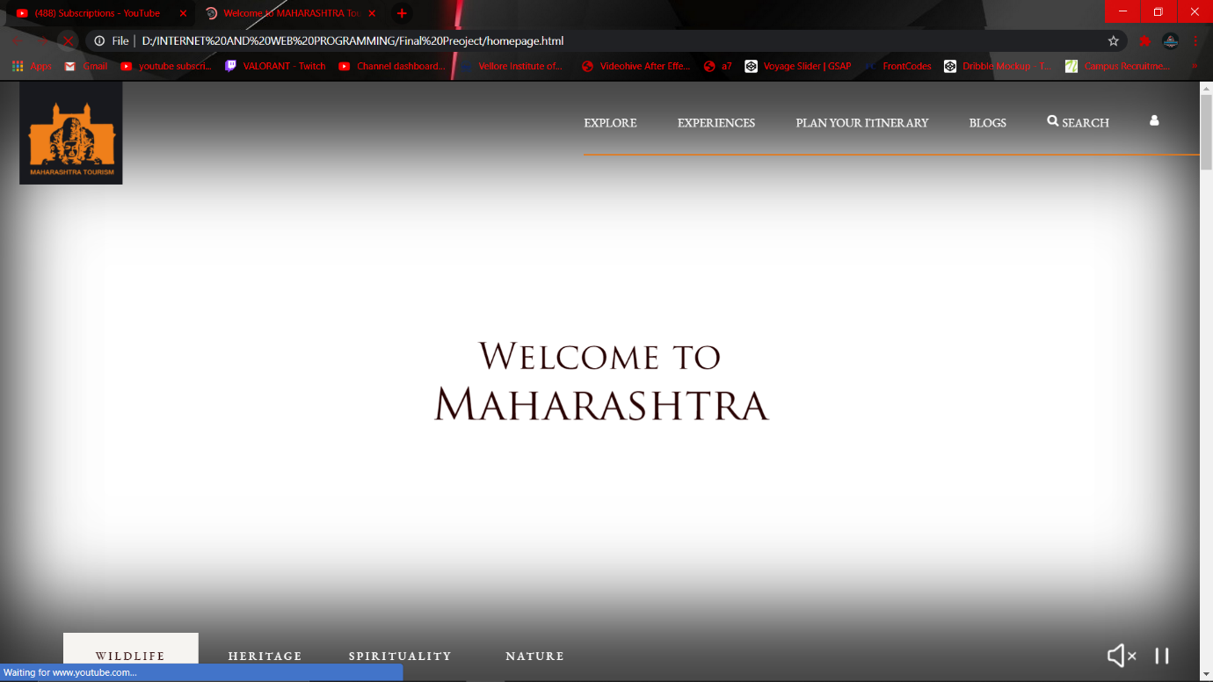

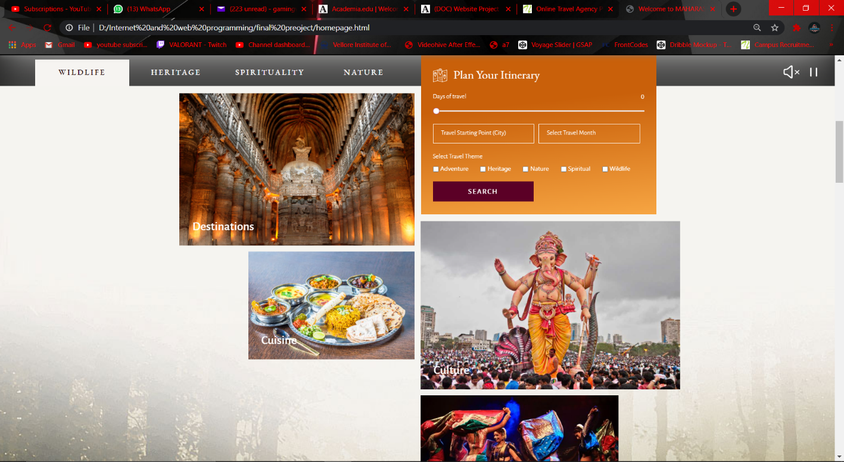

**Screenshots**

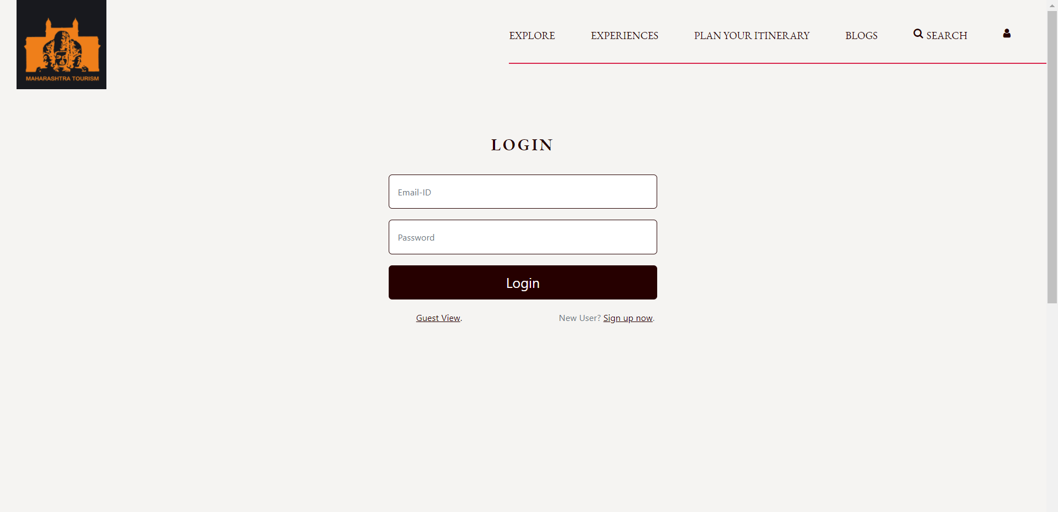

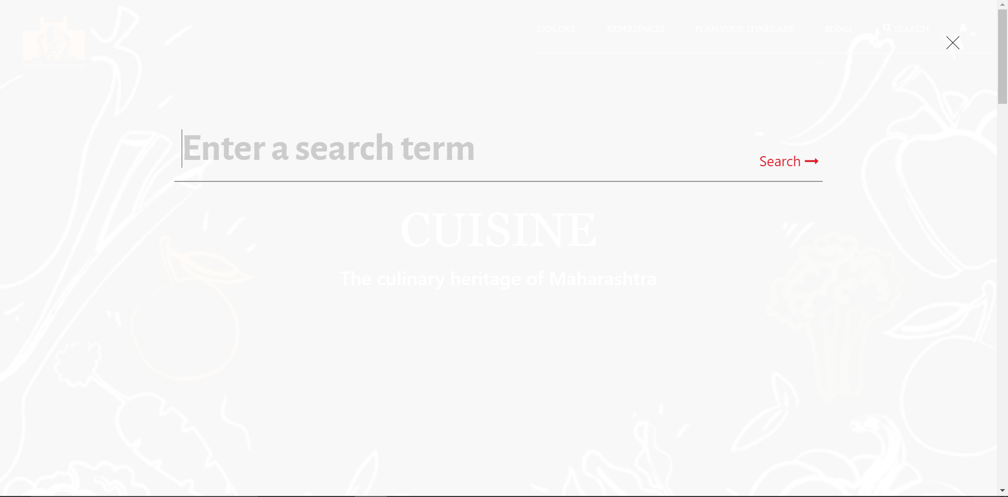

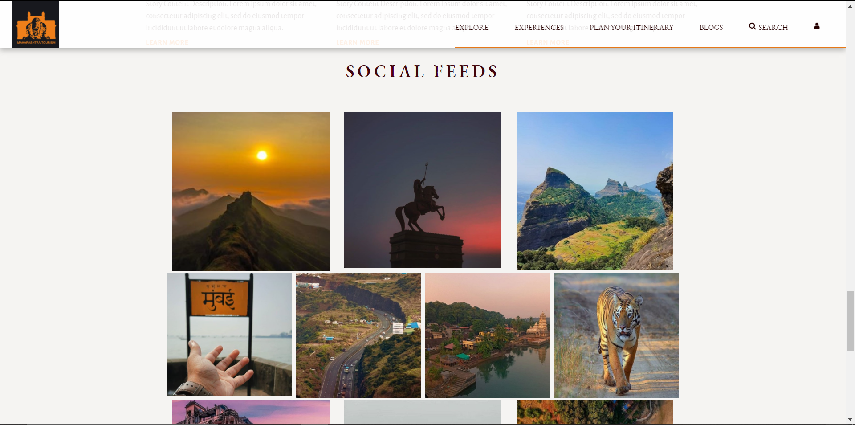

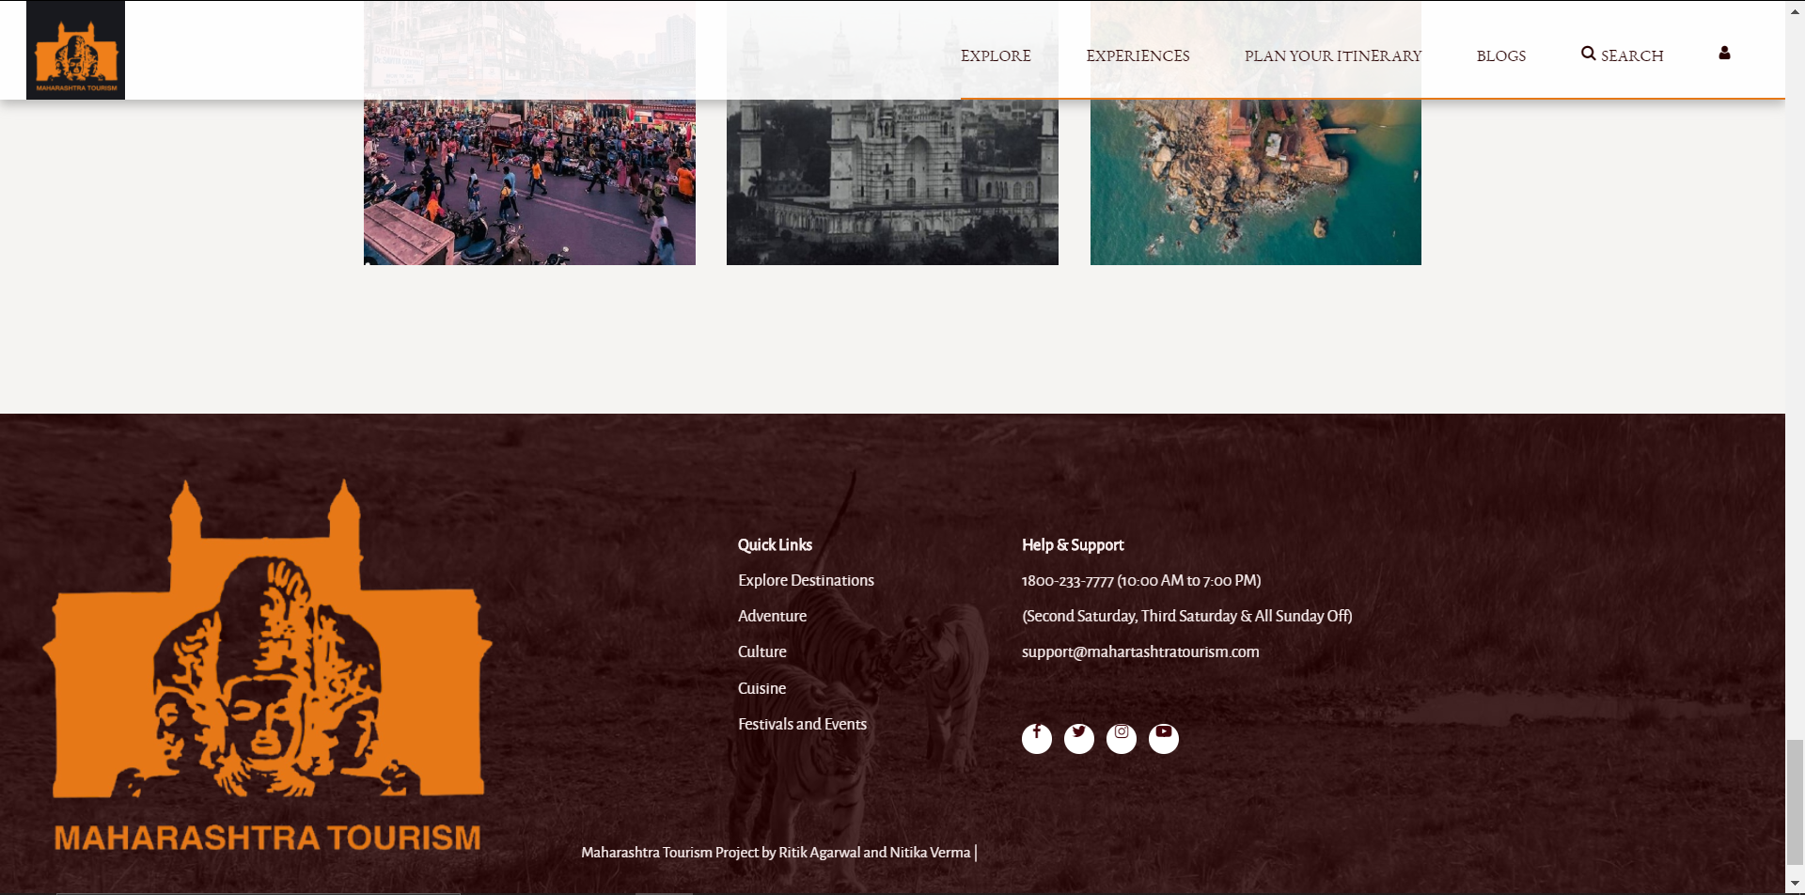

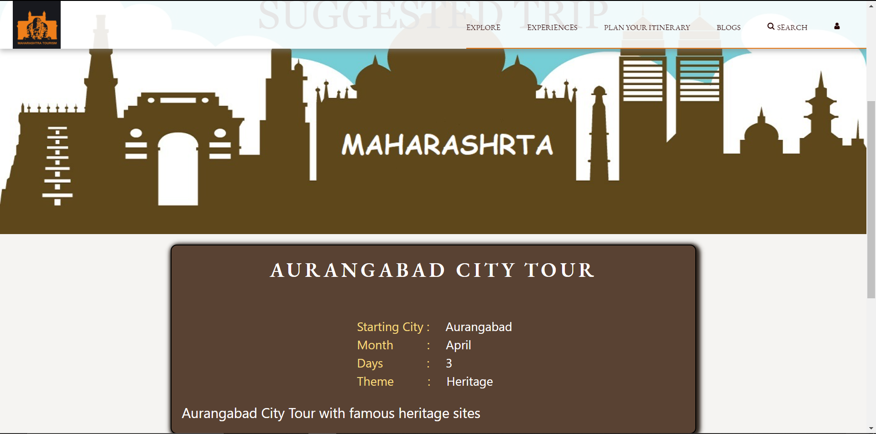

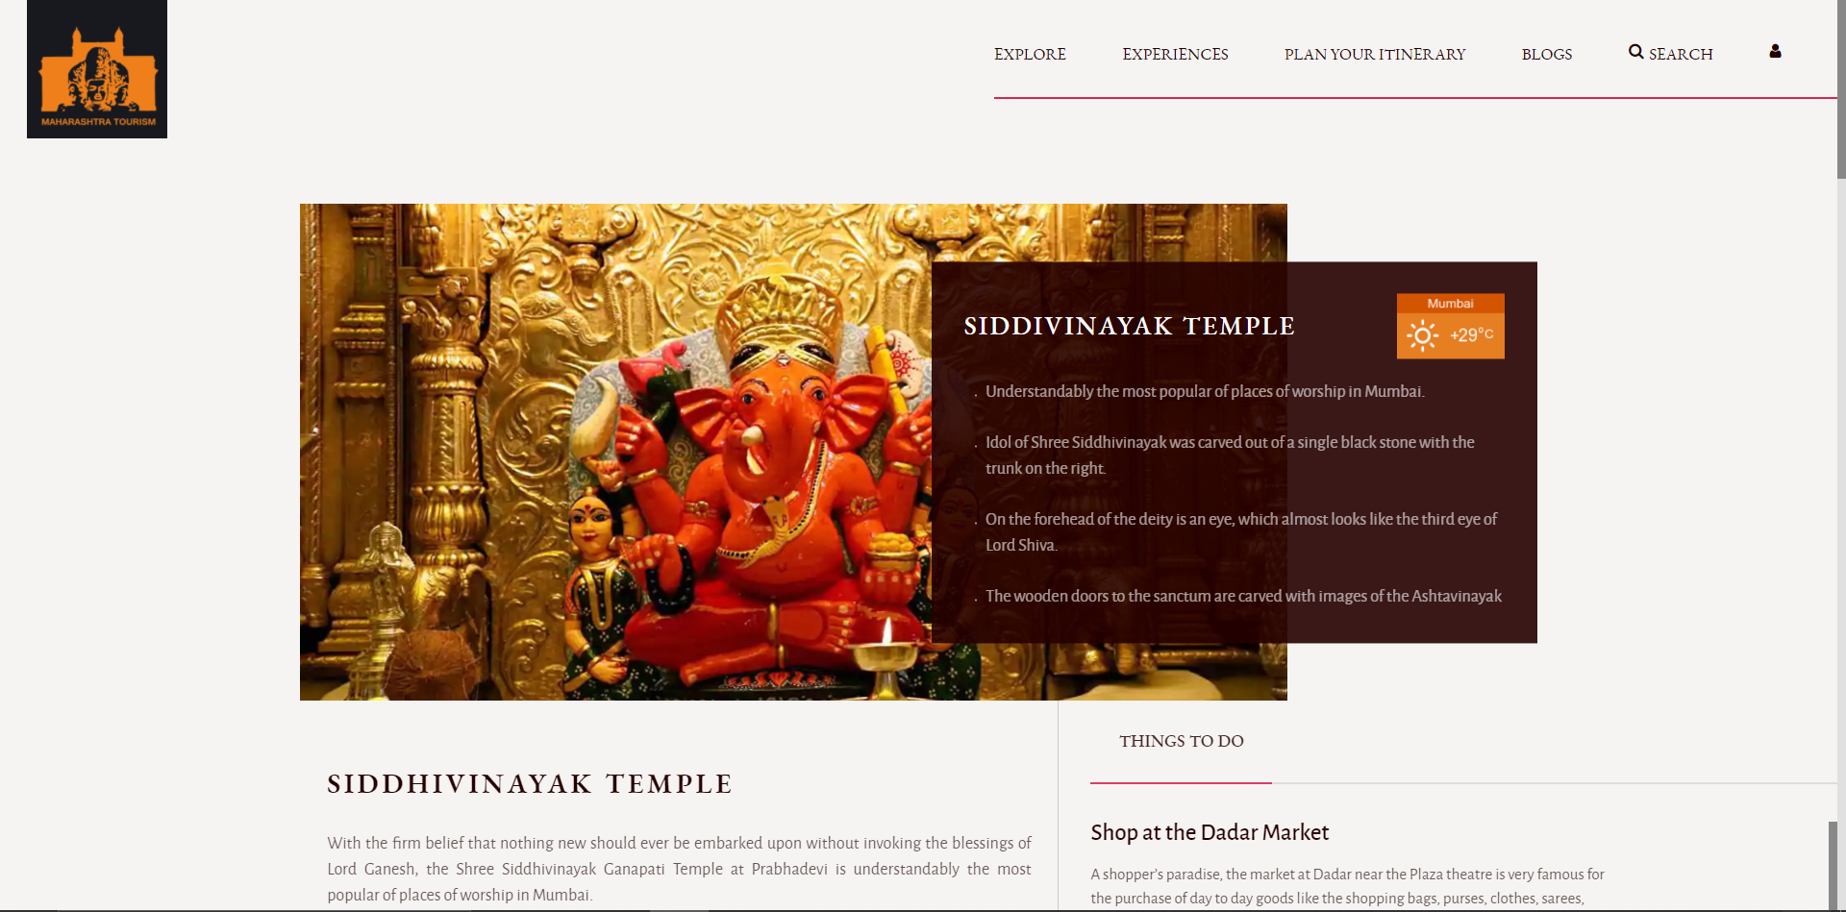

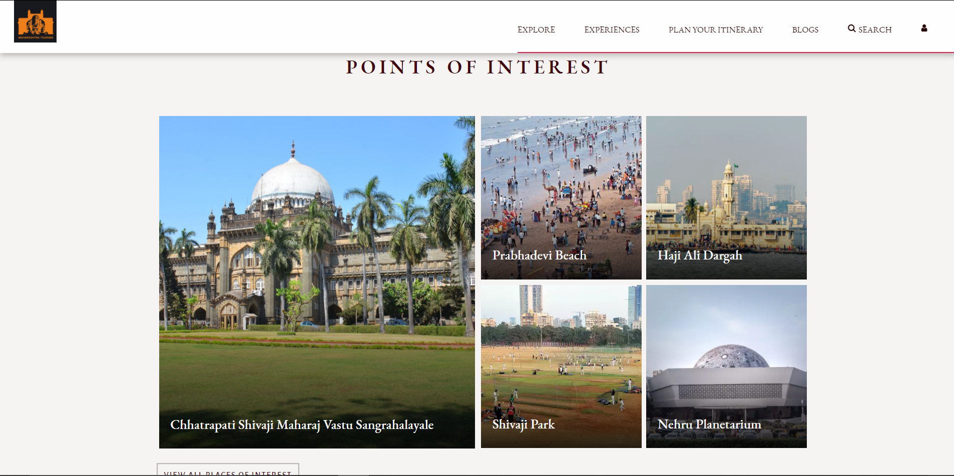

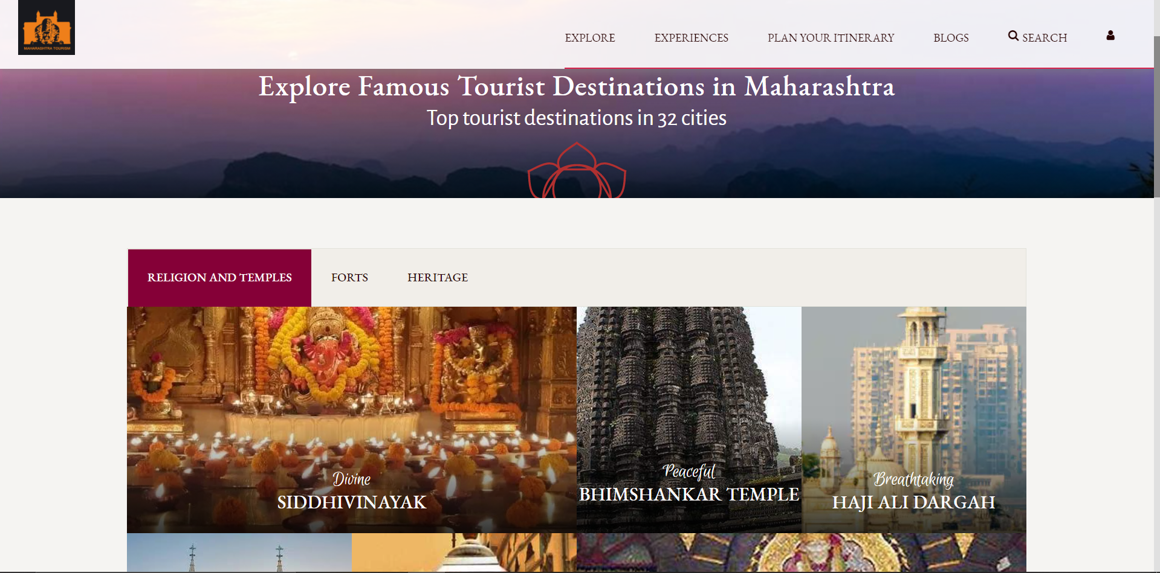

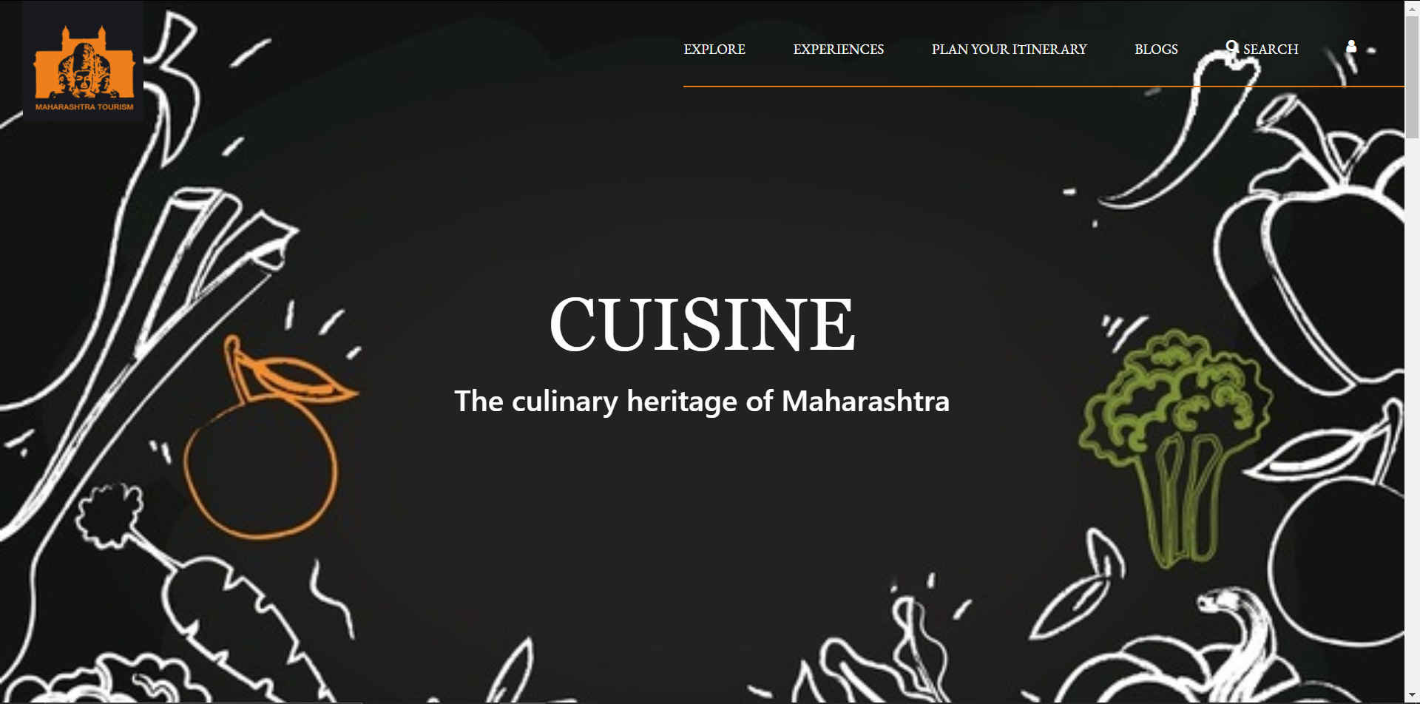

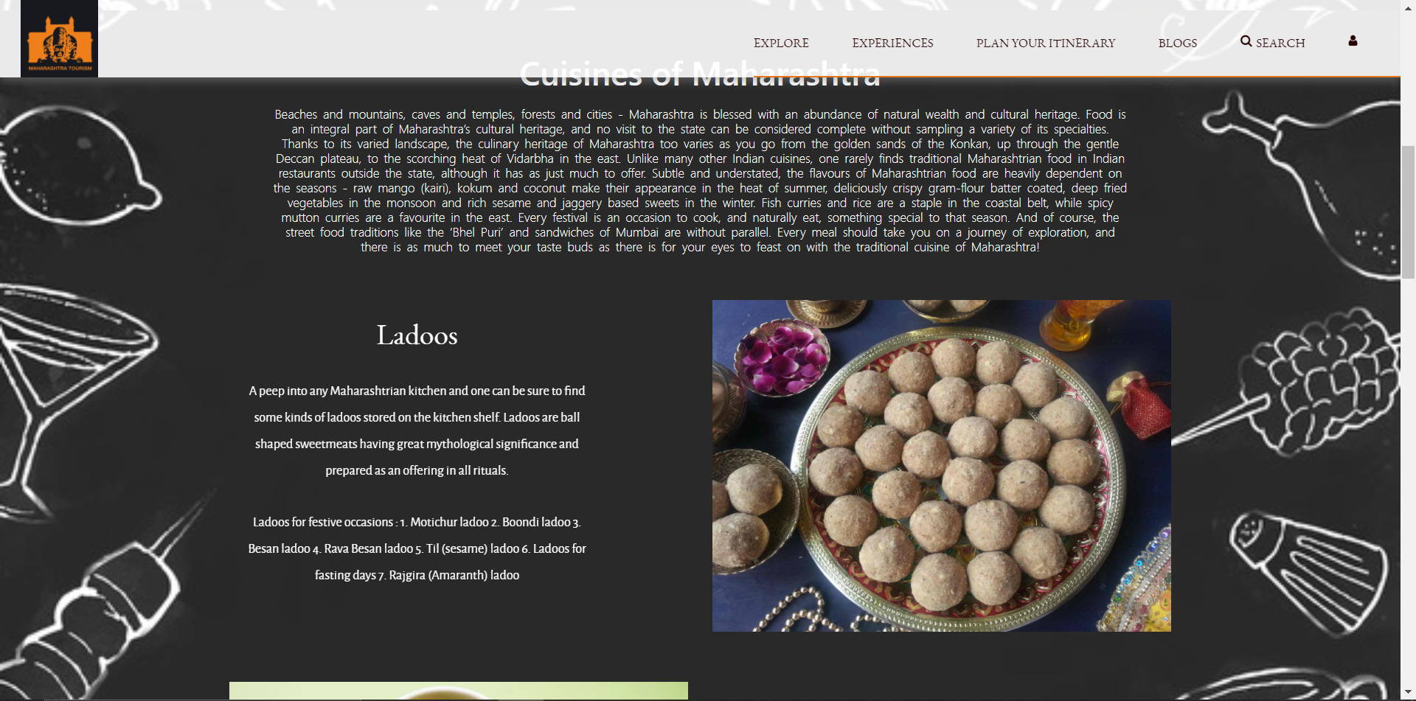

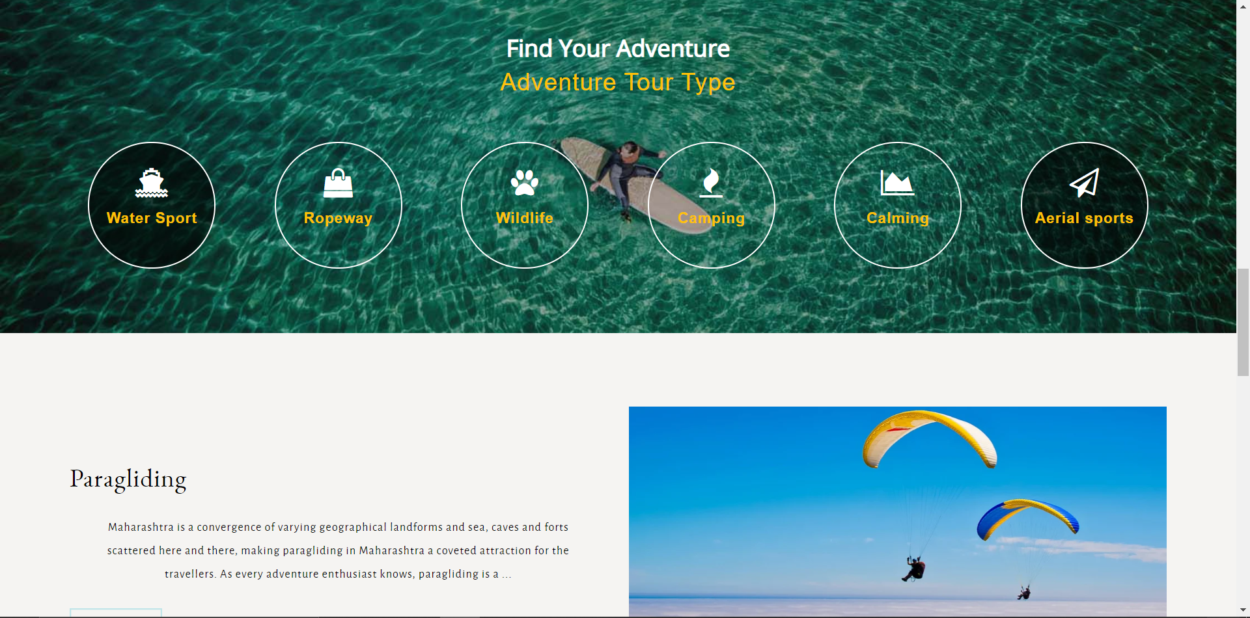

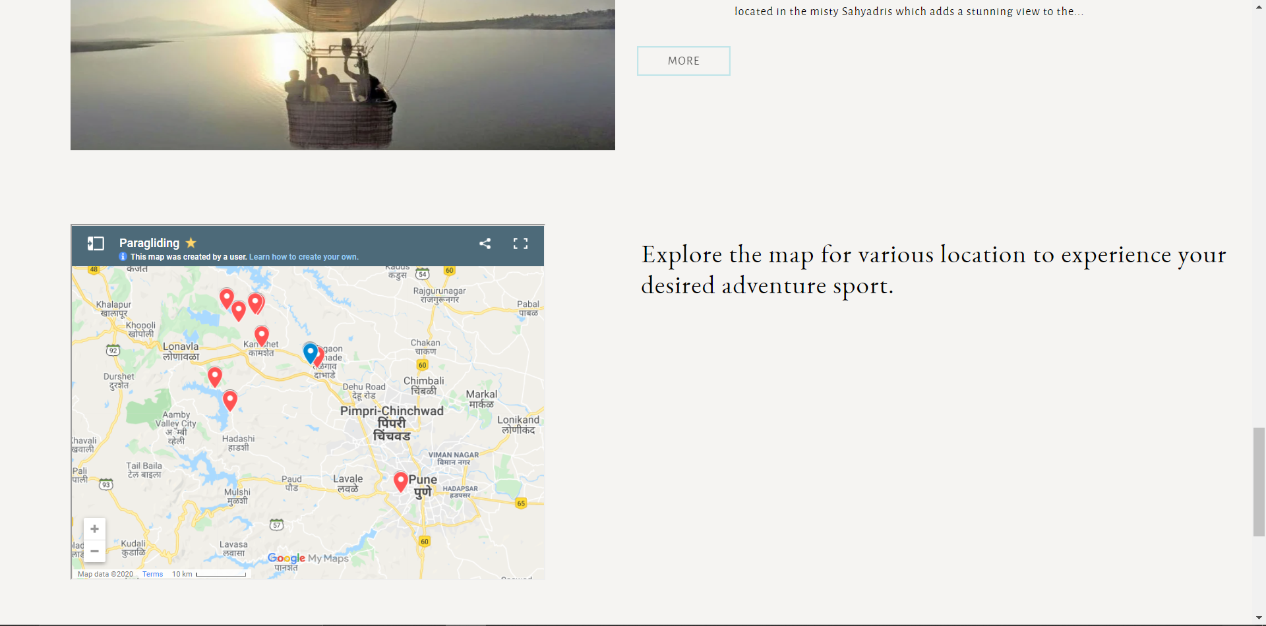

**CONCLUSION AND FUTURE WORK**

The aim of the project was to develop a centralized tourism website for tourist travelling to the State of Maharashtra. The system had all necessary information and provides different features/services to tourists which would be essential to them to plan their trip and during their trip, with a feedback feature so that the project can be improved based on user experience.

For future work, the website can provide a real-time based application which allows users to do booking at a centralized site after comparing holiday destinations and packages. The users are redirected to the main hotel site for booking. Usability issues arise when users have to jump from hotel to hotel to do their bookings. Centralized booking system lists all the hotels with their facilities information and showing the availability of the rooms in the particular hotel. The user is given different filtering option that will narrow the type of hotels the tourist wants. Selecting the type of options available for the user gives user the set of hotels available. Then the user can instantly book the room using the proposed system without going to actual website of the hotel.

**REFERENCES**

[1] Aw Yoke Cheng, & Ab Hamid, N. R. (2011). *Behavior and preferences in browsing the travel and tourism websites. 2011 IEEE Colloquium on Humanities, Science and Engineering.*

[2] Singh, V., Bali, A., Adhikthikar, A., & Chandra, R. (2014). *Web and mobile based tourist travel guide system for fiji’s tourism industry. Asia-Pacific World*

[3] Maharashtra Tourism. https://www.maharashtratourism.gov.in/.

[4] Law, R., Qi, S. and Buhalis, D.,

(2010). *Progress in tourism management: A review of website evaluation in tourism research. Tourism Management.*

[5] Mandal, S., Roy, S. and Raju, A.,

(*2016).Exploring the role of website attractiveness in travel and tourism: empirical evidence from the tourism industry in India. Tourism Planning & Development.*

[6] Bonjisse, B. and Paulo Morais, E.,

(*2017). Models for Evaluating Tourism Websites. Journal of Internet and e-business Studies, 2017.*

*[7] codepen.io*